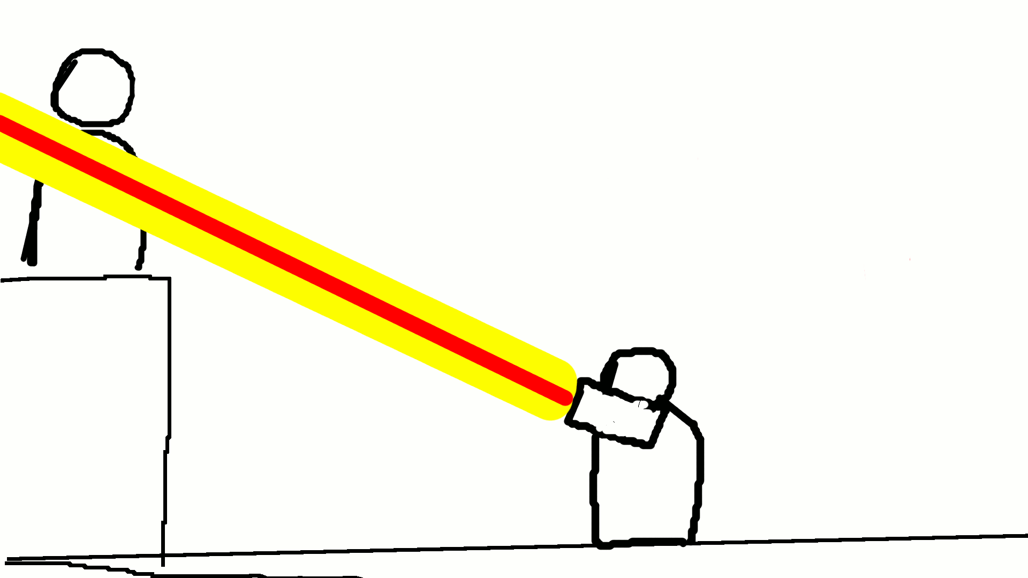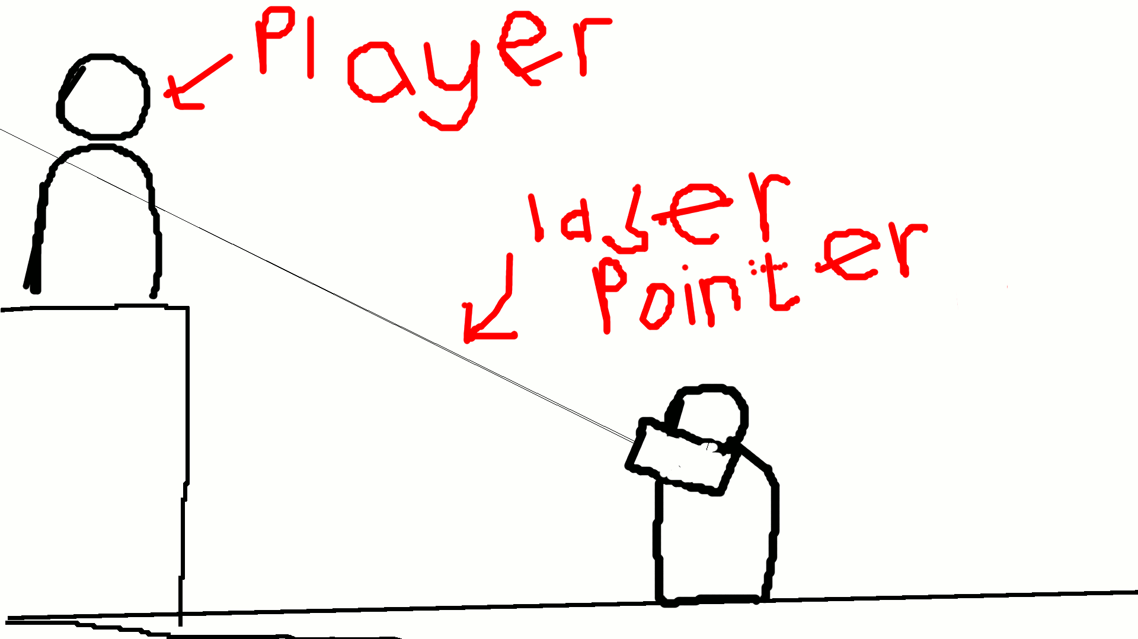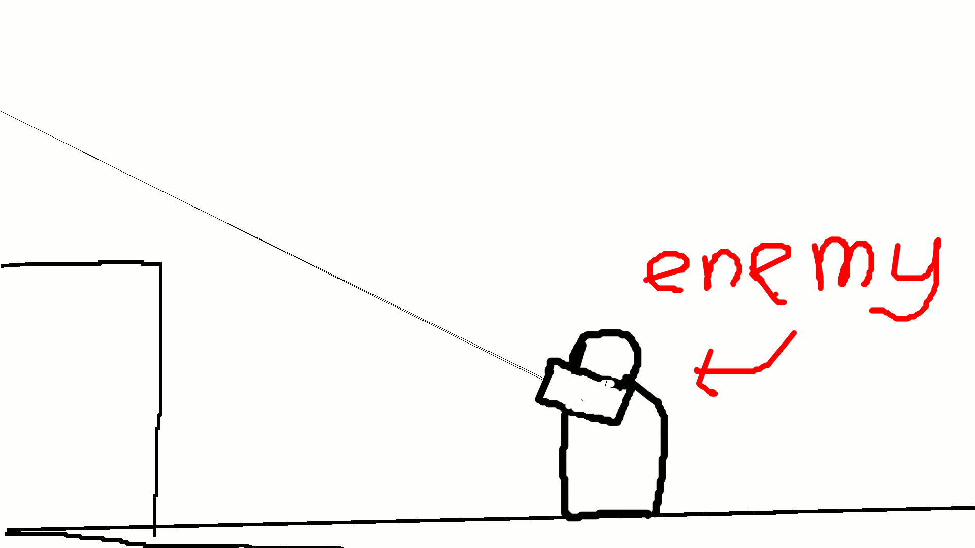**Concept for Laser Arm Cultist**

While the enemy is cooling down, the laser pointer is invisible. When they're ready to fire again, the laser pointer reappears. This is to clearly let the player know when the enemy can aim at them and when they cannot. This enemy uses path finding to slowly reposition itself to get a clear shot at the player, sweeping it's laser pointer up and down to find them

... The laser pointer becomes a thick laser beam of death. It does damage to the player then switches off. The enemy has a cool down before they can fire again.

However, as soon as the player comes in contact with the laser pointer ....HoH

Enemy searches for player, using a ray cast which is visible in game as a laser pointer. When the ray cast is not in contact with player, it appears as a thin beam.